Crime-watch documentation

Installation

1. Unzip the Application folder to a directory of your choice (this will be the directory where all files created will be saved to.
2. Execute the “run.bat” file.
3. The application is now ready to be used.

How to use the App

1. Enter a valid postcode. This app covers postcodes for the beginning with EX only.

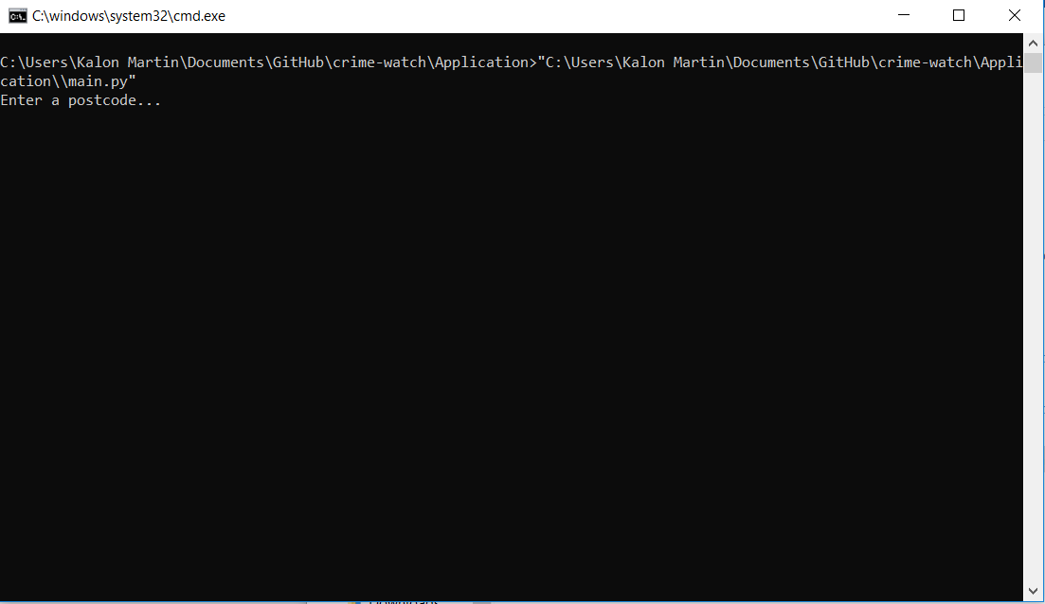

1. Enter a valid radius. The radius can be 1 , 2 , 5 (km).

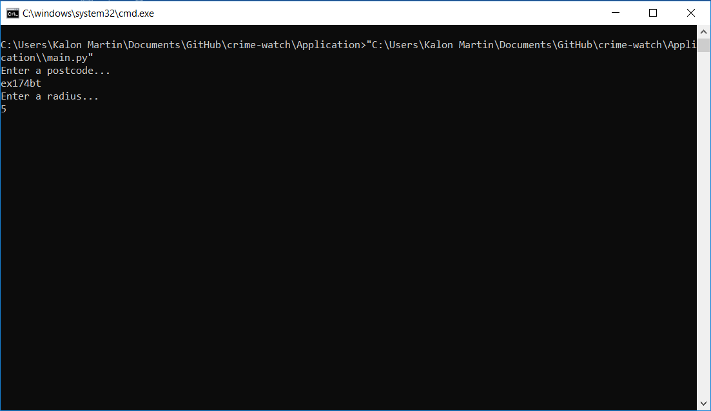

1. Report saved in application directory in the “Reports” folder.

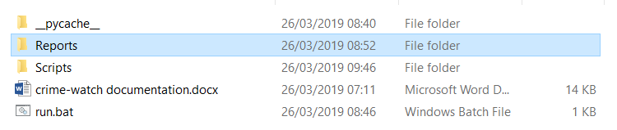

Testing